Callum Bennett

Battleship User Guide

2024

Table of Contents

Introduction 2

System Requirements 3

Hardware 3

Minimum Specs 3

Recommended Specs 3

Software 3

Installation Guide & Running the Game 4

Step 1 4

Step 2 4

Step 3 4

Step 4 5

Step 5 5

Step 6 6

Step 7 6

Step 8 7

Step 9 7

Step 10 8

Form Design 9

Start Form 9

Game Form 9

Scoring Form 10

Hints and Tips 11

Technical Support 11

Troubleshooting 11

Warranty 11

# Introduction

Listen up, soldier. As a navy admiral, I have a tremendous responsibility resting on my shoulders, one that extends far beyond the confines of this ship. In the heat of battle, every decision we make could mean the difference between victory and defeat, life and death. Now, I'm entrusting you with a critical task: choosing coordinates for our missile strikes. You must understand the gravity of this responsibility. The enemy won't hesitate to fire back with all they've got, so accuracy and strategic thinking are paramount. Lives depend on the precision of your choices. Choose wisely, and may our aim be true.

# System Requirements

## Hardware

### Minimum Specs

* ARM64 or x64 processor; Quad-core or better recommended. ARM 32 processors are not supported.
* 4 GB DDR3 RAM
* Video card that supports a minimum display resolution of WXGA (1366 by 768)
* 1 GB Storage Free

### Recommended Specs

* ARM64 or x64 processor; Quad-core or better recommended. ARM 32 processors are not supported.
* 8 GB DDR4 RAM
* Video card that supports a minimum display resolution of 1920 by 1080 or higher.

## Software

* .NET 8 Runtime installed and working.[1]
* A fully working edition of Windows 11.[2]
* Screen scaling at 100% resolution.

# Installation Guide & Running the Game

## Step 1

Download the file *Bennett Callum Stage 3.zip* from the internet*.*

## Step 2

Locate where this file has downloaded to. It will most likely be in the *Downloads* folder.

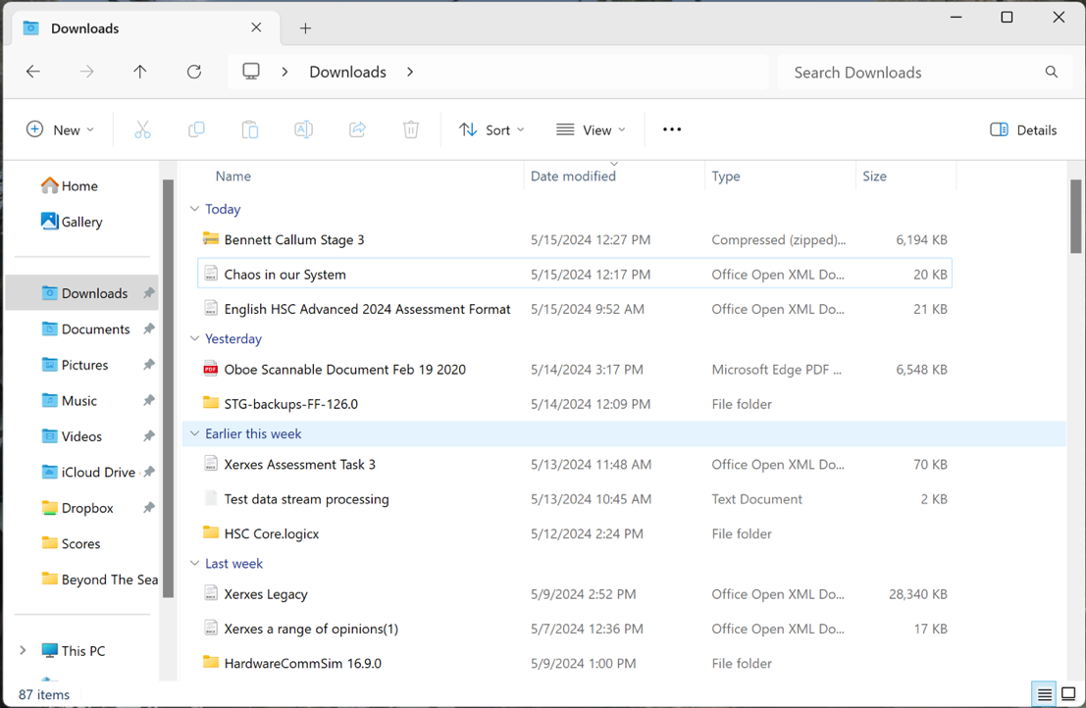

## Step 3

Click on the Folder. You will now see a new option in the menu bar labelled *Extract All.* Click this button. 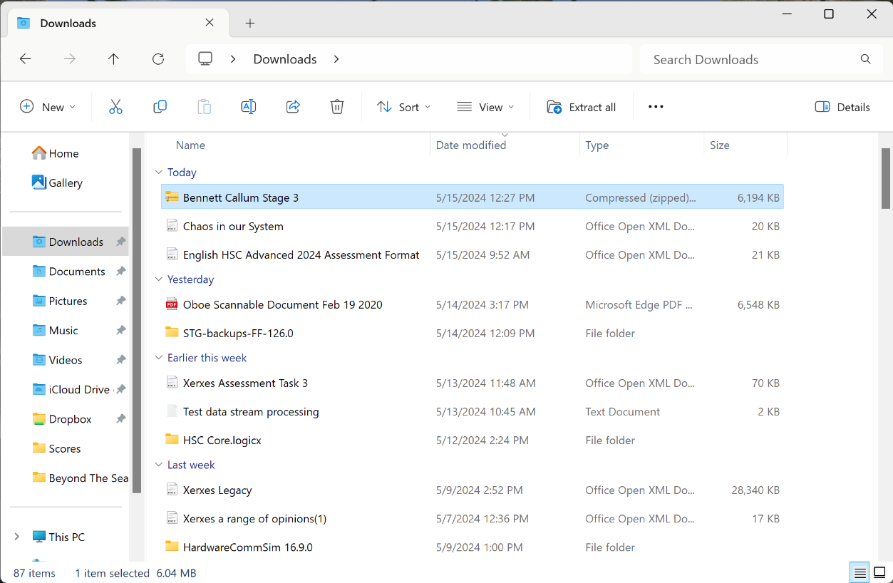

## Step 4

A prompt will ask where to save the extracted files. Make sure *Show extracted files when complete* is selected. Click *Extract*. 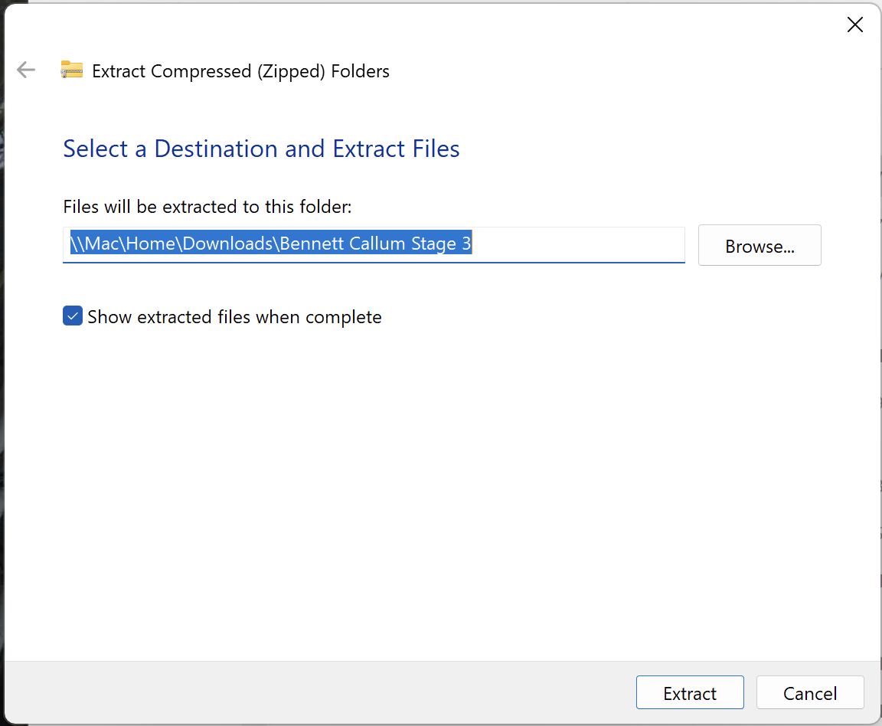

## Step 5

A new window will open with the resulting folder. Double click the folder labelled *battleship* to open it. 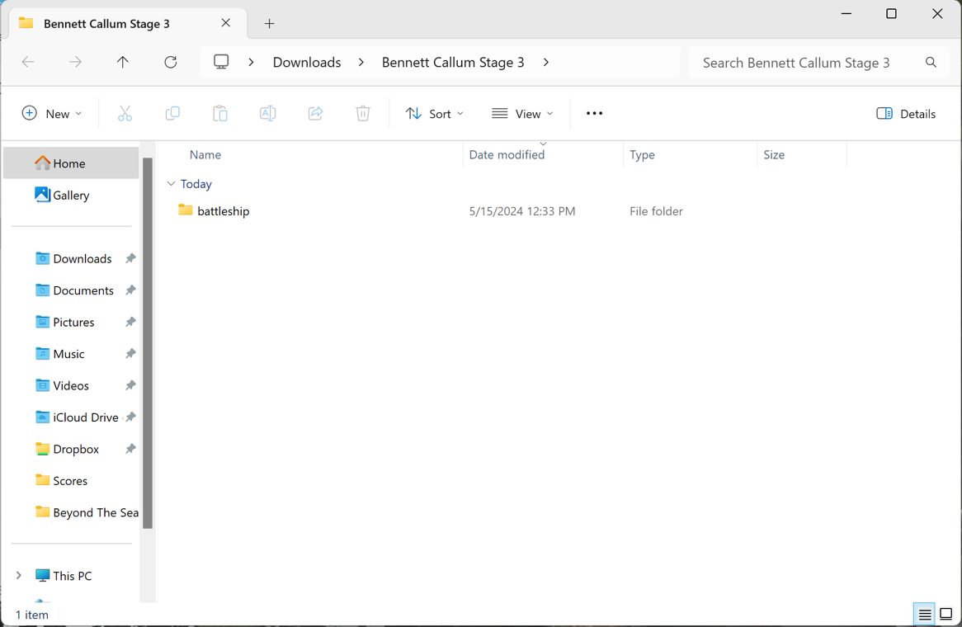

## Step 6

Double click the folder labelled *Game Files* to open it. 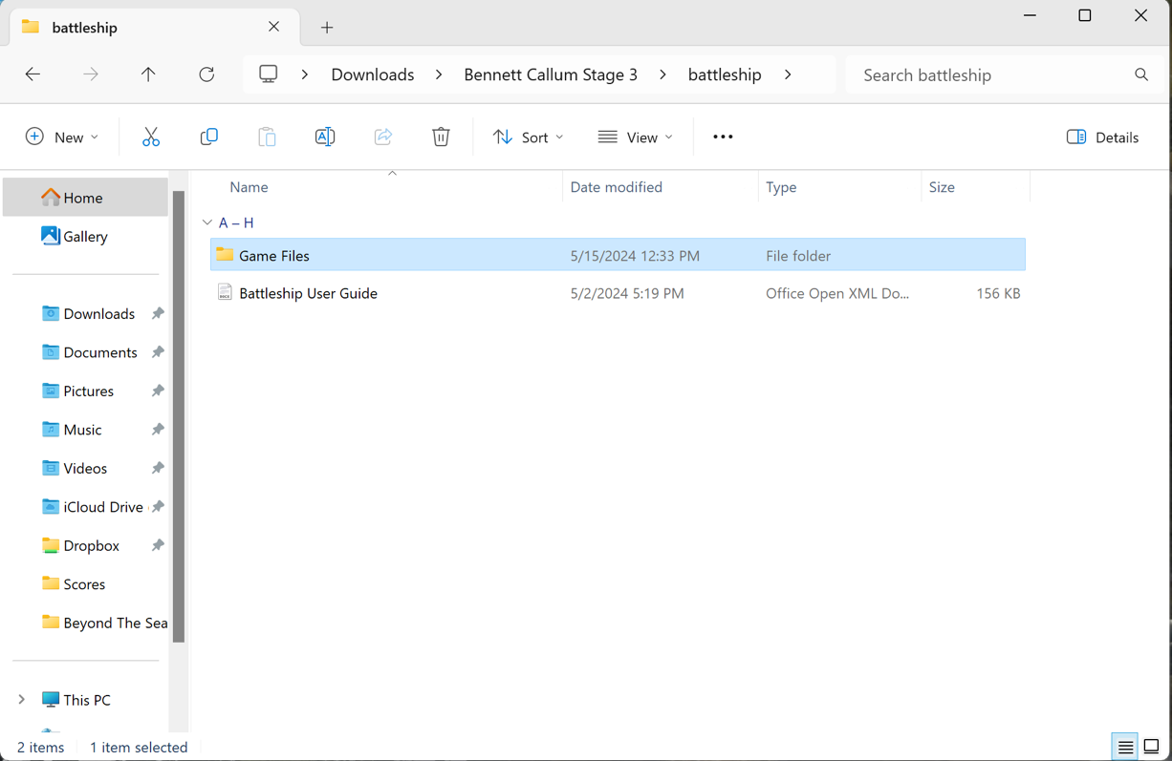

## Step 7

In this folder locate the *bin* folder. Double click to open it. 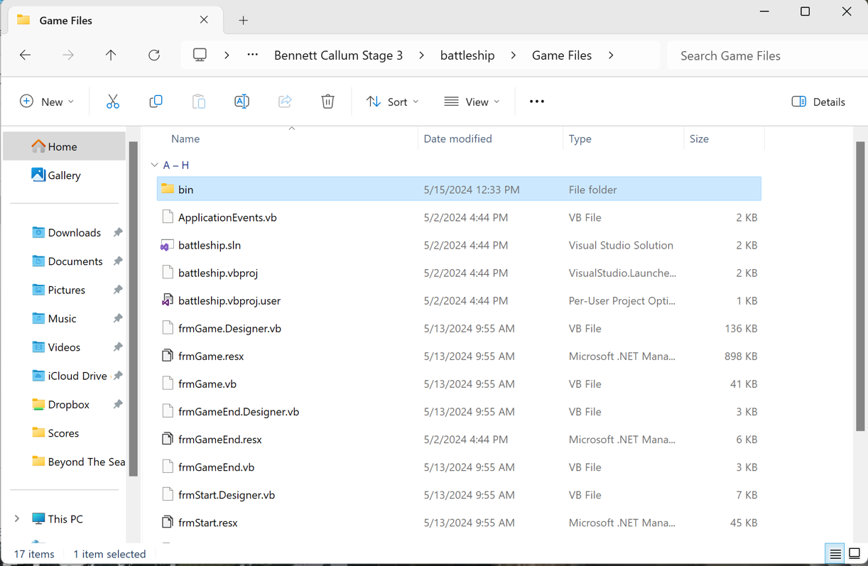

## Step 8

In this folder locate the *debug* folder. Double click to open it. 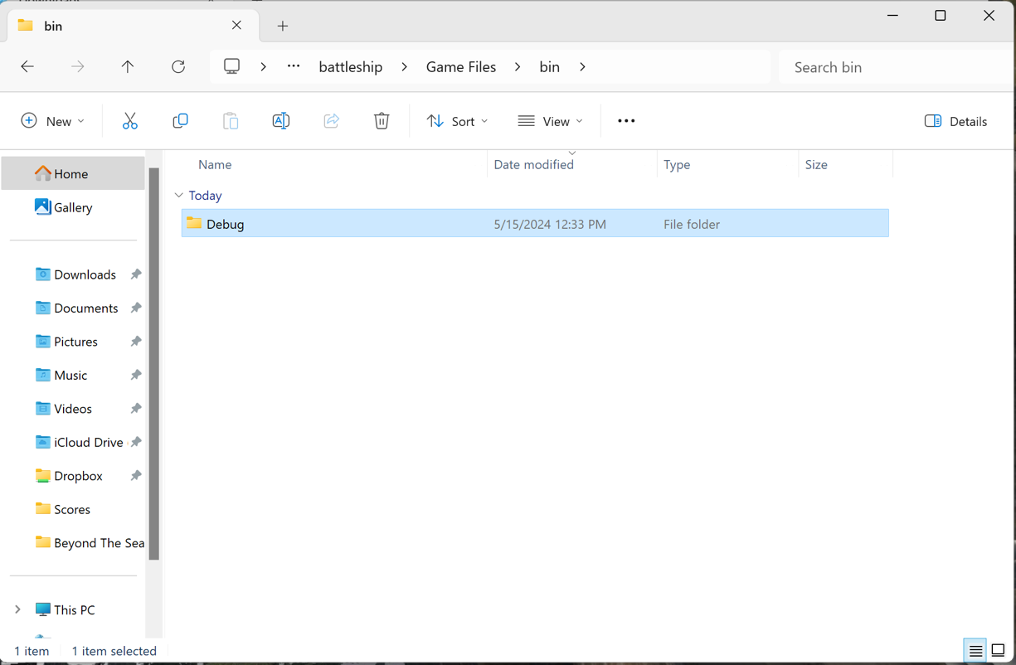

## Step 9

In this folder locate the *net8.0-windows* folder. Double click to open it.

## Step 10

In this folder locate *battleship.exe.* It may just be referenced as battleship with type *Application.* Double click the file to run the game. 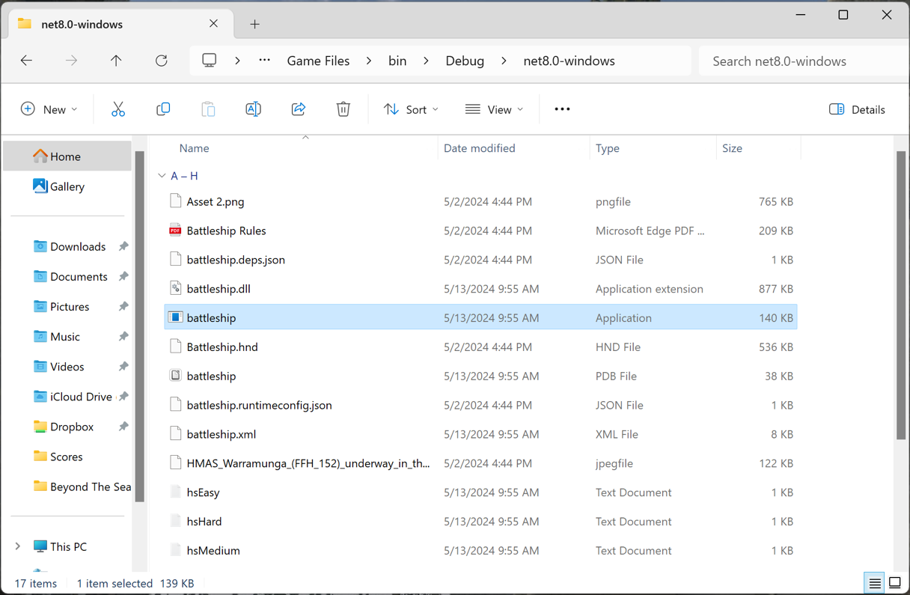

# Form Design

## Start Form

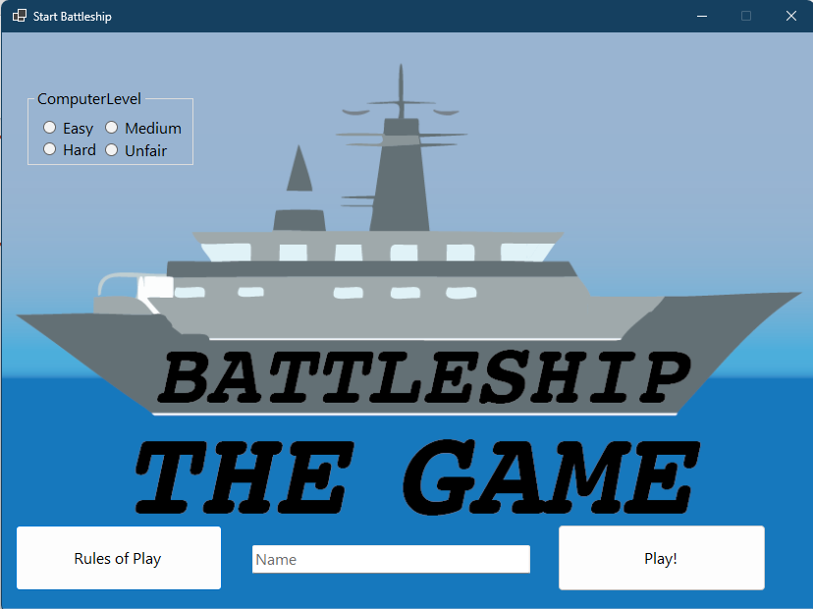

The start form allows the user to select a computer level, enter their name, play the tutorial or start the game. To start a game, select a game mode, enter a name between 2 and 10 characters.

## Game Form

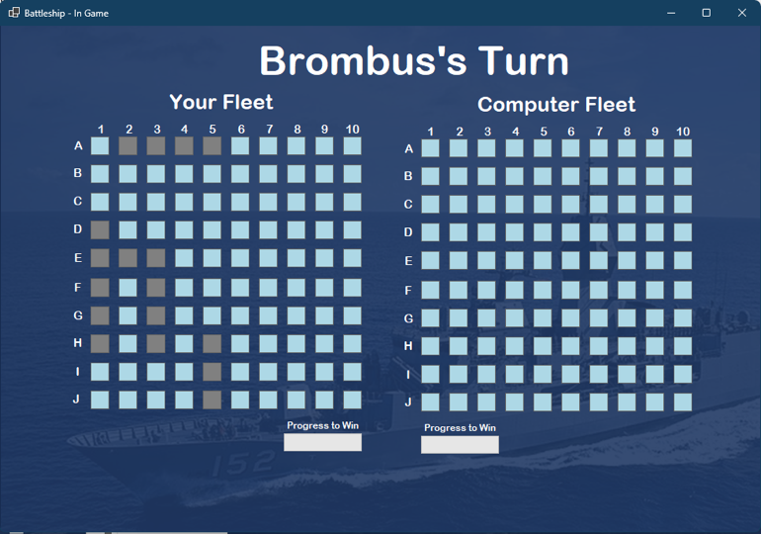

In the main form, the user has the option to click coordinates on the Computer Fleet. It will then flash purple twice, before settling on a solid red or blue to indicate a hit or miss.

## Scoring Form

The scoring form displays the top 11 scores. It will store the top 10. In this example, Jed’s result will be overwritten due to our player Brombus receiving a higher score.

# Hints and Tips

* The computer easy level is easier to beat than hard! Work your way up to the hard level.

# Technical Support

## Troubleshooting

|  |  |  |
| --- | --- | --- |
| **Problem** | **Cause** | **Fix** |
| A window opens displaying “Windows protected your PC” | Windows Security | Click “More info”, then click the “Run” button that appears in the bottom right next to don’t run. |
| My name isn’t typing into the box | Text box isn’t selected | Click on the text box. Your cursor should change indicating text entry. |
| It says get a new name | Name is invalid | Make sure your name has between 3 and 10 characters |
| It won’t start, telling me I need to select a game mode | Game mode not selected | Make sure one of the four computer levels is selected |
| It tells me my move is invalid, and then the computer makes a move. | Penalty for selecting same coordinate | There is a one-turn penalty for selecting the same coordinate twice. |

# Warranty

The developer grants you an exclusive, revokable, conditional license to use the software.

By launching this software product, you acknowledge the following:

* that the software product is provided as-is.
* You may not modify any part of the program.
* You may not attempt to modify any part of the program.
* You may not attempt to reverse engineer or gain access to any of the program.
* You may not distribute the program without written permission from the developer.
* The developer owns every copy of the software program.
* You will not sue the developer over functions of the program.
* You are responsible for your device. You cannot hold the developer or program responsible if your device is to break in any way while running the program.
* The software is not a security risk. If your device encounters a virus, it is not the fault of the developer.
* You acknowledge the developer has full unrestricted rights over every copy of
* These terms are legally binding. By continuing to use the software you agree to the terms.

The Developer has sole, unrestricted ownership over every copy of the program. You may not challenge any of these terms. By doing so you revoke your license to the software.

1. See [dotnet.microsoft.com](http://dotnet.microsoft.com/) for more details on installation.
2. Windows 10 can be used but is not covered in this guide.